Engaging in data dialogues

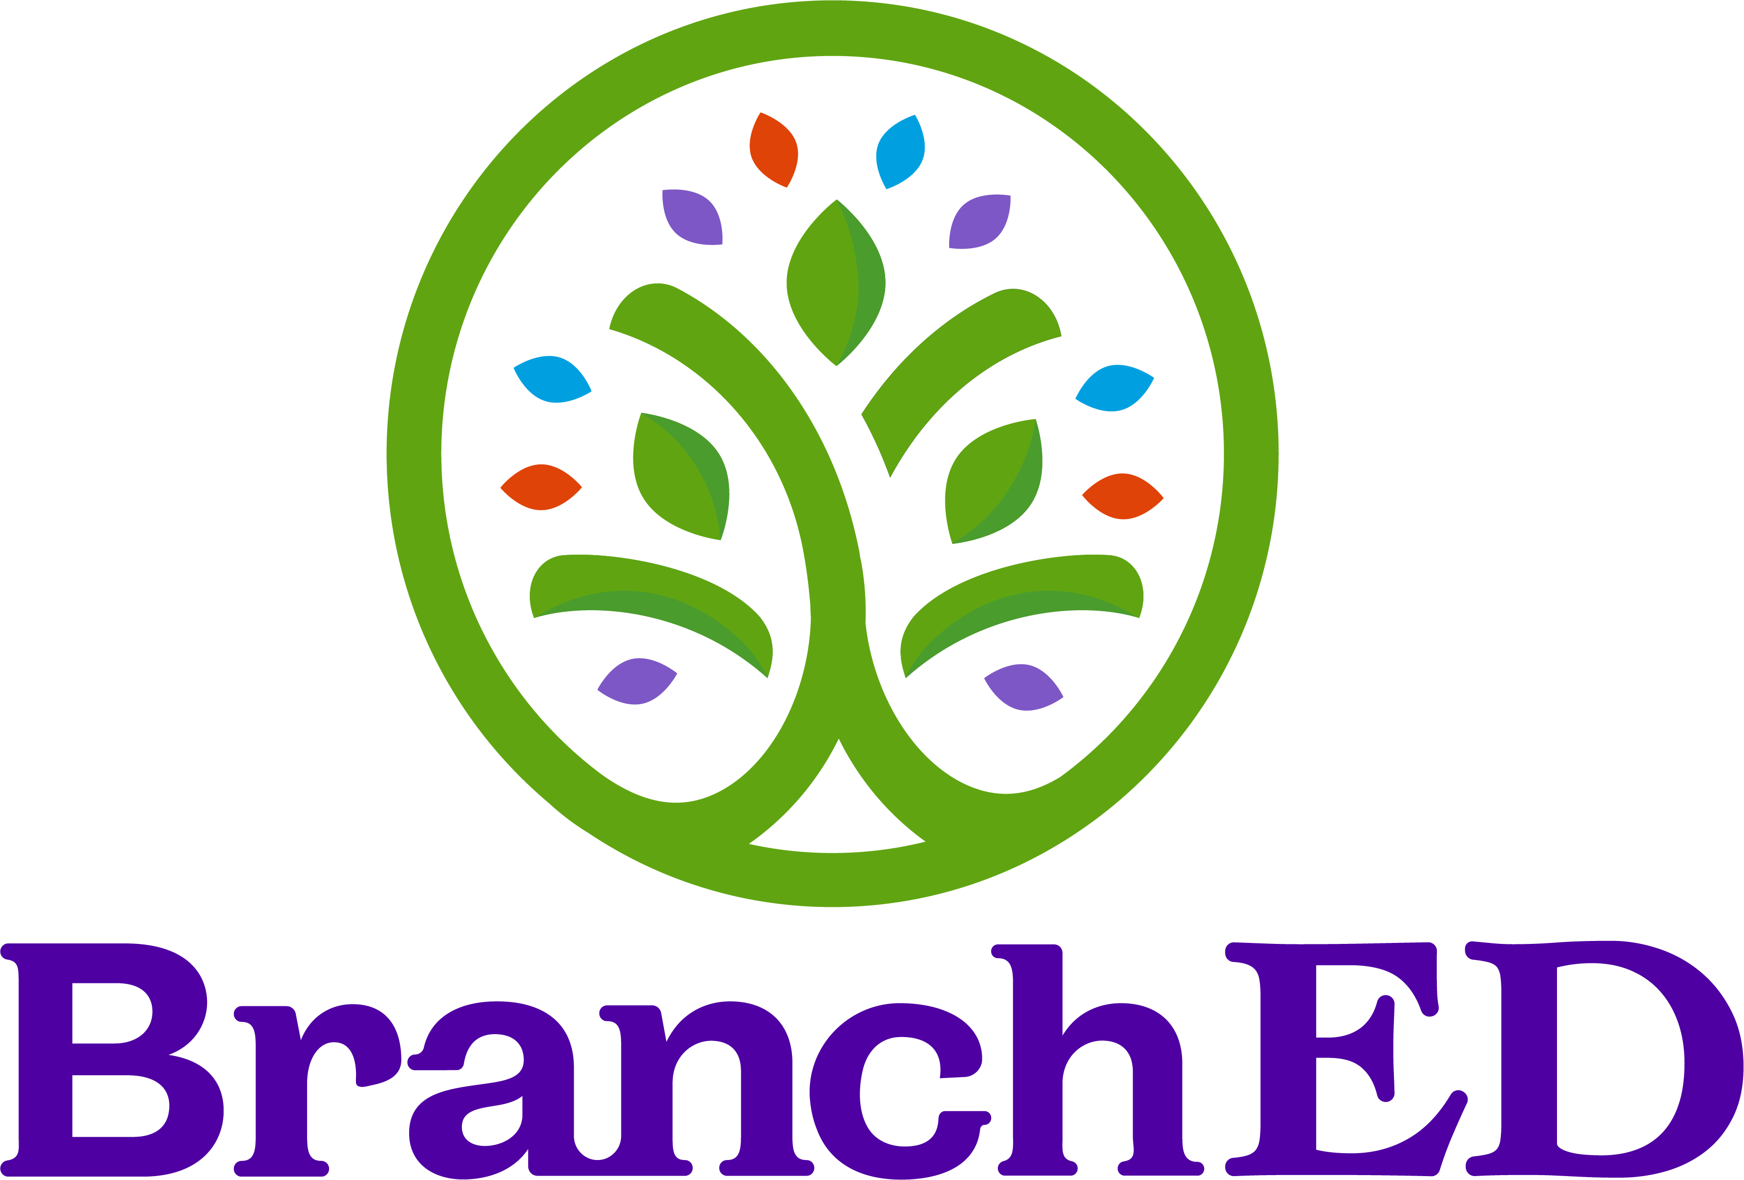

Table of Contents
Data Dialogues versus Data Discussions 3
Process1F 3
Format 3
Case Study 4
The Charge 5
Predictions 6
The Data 7
Domain Areas and Corresponding Competencies 7
Percent of Available Points Earned for all 3 Cohorts 8
Percent of Available Points for Domain 1 Competencies by Cohort 8
Percent of Available Points for Domain 2 Competencies by Cohort 8
Percent of Available Points for Domain 3 Competencies by Cohort 9
Percent of Available Points for Domain 4 Competencies by Cohort 9
Create a Visual Representation of the Data 10
Focusing on a Specific Aspect of the Data 12
Hypothesizing 12
Appendix 13
The Charge 14
Predictions 15
The Data 16
Create a Visual Representation of the Data 17
Focusing on a Specific Aspect of the Data 19
Hypothesizing 19
Action Plan 20
Progress Monitoring Schedule 20



Engaging in Data Dialogues MARCH 2024
Published by Branch Alliance for Educator Diversity, an imprint of M.E.B. Alliance for Educator Diversity, Inc., 100 World Drive, Suite 101, Peachtree City, GA 30269

https://www.educatordiversity.org

The content herein is licensed CC-BY-NC-SA. It can be shared and remixed for noncommercial purposes with attribution to BranchED.

Engaging in Data Dialogues

“A dialogue is listening with an open spirit.”0F

Branch Alliance for Educator Diversity is a professional services organization and a collective of university faculty and leaders advancing educational equity and excellence by expanding individual capacity, enabling supportive relationships, boosting institutions effectiveness, and collaborating with communities. We believe every student deserves access to caring, adaptive, and well-prepared teachers; every teacher deserves preparation that fuses quality with diversity, and every person benefits when we create a higher standard of education together.

The BranchED Framework for the Quality Preparation of Educators⁷ informs programmatic transformation, which guides the development and enhancement of equity-oriented educator preparation programs that prepare educators to reflect, respect, and reify the value of the diversity of America’s PK-12 school children. The Framework is the lens through which the organization looks at, provides feedback to, supports continuous improvement efforts of, and innovates with Educator Preparation Providers (EPPs). It is the bedrock of all the organization’s activities.

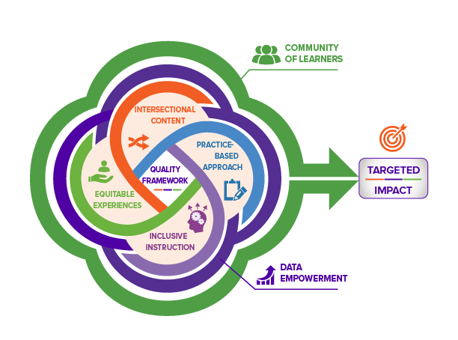
It is unique, in that it focuses on six design principles that high-quality educator preparation programs implement to ensure graduates are competent and confident educators able to leverage, not fear or ignore, the differences among their students. Two of these design principles (Community of Learners and Data Empowerment) provide the foundation for the remaining design principles: Practice-Based Approach, Inclusive Instruction, Equitable Experiences, and Intersectional Content.

This resource is situated within the Data Empowerment Principle. Data empowerment is defined as empowering individuals and the collective to access and engage with their own data to improve their community.
An essential component of Data Empowerment is engaging stakeholders in meaningful exploration and analysis of data as well as problem solving and closing the loop based on data leading to program improvement. This requires ensuring stakeholders are active participants in the process through structured dialogue.

Data Dialogues versus Data Discussions

There is a distinct difference between dialogue and discussion. In a dialogue, there is a free flow of communication amongst participants as they exchange and respond to ideas presented. It entails listening and asking questions to reach an understanding of the phenomena being addressed. In a discussion the exchange of information is undertaken with the express goal of decision making, which often results in participants emphasizing the validity of their ideas versus being open to others’ ideas.

Effective dialogue requires participants to suspend judgement, identify and explore assumptions, inquire, and reflect, and, most importantly, listen. This resource provides participants with a process for engaging with data and developing a shared understanding that supports continuous improvement efforts.

Process1F

Format
We begin by providing a case study to demonstrate the process for meaningful data engagement. A template of the process is provided in Appendix A. We encourage you to follow the sequence of activities as delineated in the process, especially providing stakeholders information pertaining to the context in which your work is situated and surfacing assumptions that may hinder identification of solutions leading to project improvement.

Case Study
Context: The College of Education

The college has been preparing educators since its establishment in the late 1800s as a teacher training college. The institution is a federally designated Minority Serving Institution (MSI); approximately half of their students in the teacher preparation program (TPP) are from diverse backgrounds. The majority are female. Although the TPP saw some increases in enrollment during the pandemic, there has been a steady decline in enrollment over the past 5 years. Further, there is concern about lower pass rates on certification exams and other high stakes assessments. An increasing number of students have or want to graduate without certification. They believe doing so affords them additional time to pass the certification exams. This is negatively impacting the districts as well as the college. Additionally, for-profit alternative teacher preparation providers are on the increase. The college recognizes that it is essential to demonstrate the quality of its graduates both quantitatively and qualitatively, including their ability to positively impact student learning.

Faculty are committed to preparing high quality educators to meet the needs of the PK-12 students in the three districts that are served by the college and recognize that their continuous improvement efforts have been superficial and focused on compliance. The majority of students in the college remain and teach in the area. At the most recent college faculty meeting, the criticality of the issue became apparent and there was overwhelming agreement of the need to move to a culture of inquiry and build data literacy capacity within faculty, students, and staff.

Context: Where the EPP students come from.

The college is located in a metropolitan area. The majority of its students are locals, having attended one of the three districts within the college service area. In addition, approximately 25% of their students enter the college with some undergraduate credit obtained through dual credit course work (up to 60 hours) or an associate degree obtained from the local community college.

There is wide variation in the districts served by the University. For example, District A is in an area referred to by locals as Suitcase City because of its large transient population. Most residents are diverse, and most live at or below the poverty line. Students in this district are more likely to be taught by novice teachers and/or teachers teaching out of field. There is little access to rigorous coursework, high absentee rates, and punitive disciplinary practices. Graduates from these districts who go on to post-secondary education are more likely to receive Pell Grants and be first-generation college students. Many begin their post-secondary work at the local community college.

The community served by District B is further away from the university in an area experiencing gentrification. Young professionals have “discovered” this area as the new trendy place to live. As such, many of the current inhabitants are being displaced as they are priced out of the area. Residents (new and existing) are diverse. There is a wide disparity in income levels. The influx of wealthier families is also impacting on schools in this area (e.g., increased tax base resulting in increased funding for the schools).

District C is in a new area annexed by the city in 2000 that is called New Berkshire. It boasts planned residential communities, most of which are gated and governed by strong homeowners’ associations. Individuals living in this area are predominantly white and affluent. Students from this district who attend the university come in with Advanced Placement credit or Early College credit reducing their debt load for college. They also have had less interaction with diverse populations.

The Community College is instrumental to the community. It provides an affordable alternative to higher education and provide programs to meet current workforce needs. The community college works closely with the local districts to support dual credit offerings. Many of their graduates go on to complete their teaching degree at the College of Education. As noted above 25% of students entering the college have taken courses and/or completed associate degrees through the community college.

The Charge

The college has convened faculty and key stakeholders to engage in a data dialogue regarding pass rates on the pedagogical teacher certification exam for 3 cohorts (2019, 2020, 2021).

Predictions
Predictions take place before you see the data. Independently, activate prior knowledge, surface assumptions, and make predictions in preparation for examining and discussing the data.
- Independently: Respond to the following prompts.
- Whole Group: Share predictions.

I assume…

I predict….

I wonder…

My questions/expectations are influenced by…

The Data
The exams consists of 13 competencies subsumed under 4 domain areas. The goal is to surface bright spots and opportunities and identify next steps for program improvement.

Domain Areas and Corresponding Competencies

DOMAIN I: DESIGNING INSTRUCTION AND ASSESSMENT TO PROMOTE STUDENT LEARNING
Competency 001 | The teacher understands human developmental processes and applies this knowledge to plan instruction and ongoing assessment that motivate students and are responsive to their developmental characteristics and needs.
Competency 002 | The teacher understands student diversity and knows how to plan learning experiences and design assignments that are responsive to differences among students and that promote all students learning.
Competency 003 | The teacher understands procedures for designing effective and coherent instruction and assessment based on appropriate learning goals and objectives.
Competency 004 | The teacher understands learning processes and factors that impact student learning and demonstrates this knowledge by planning effective, engaging instruction and appropriate assessments.

DOMAIN II: CREATING A POSITIVE, PRODUCTIVE CLASSROOM ENVIRONMENT
Competency 005 | The teacher knows how to establish a classroom climate that fosters learning, equity and excellence and uses this knowledge to create a physical and emotional environment that is safe and productive.
Competency 006 | The teacher understands strategies for creating an organized and productive learning environment and for managing student behavior.

DOMAIN III: IMPLEMENTING EFFECTIVE, RESPONSIVE INSTRUCTION AND ASSESSMENT
Competency 007 | The teacher understands and applies principles and strategies for communicating effectively in varied teaching and learning contexts.
Competency 008 | The teacher provides appropriate instruction that actively engages students in the learning process.
Competency 009 | The teacher incorporates the effective use of technology to plan, organize, deliver, and evaluate instruction for all students.
Competency 010 | The teacher monitors student performance and achievement; provides students with timely, high-quality feedback; and responds flexibly to promote learning for all students.

DOMAIN IV: FULFILLING PROFESSIONAL ROLES AND RESPONSIBILITIES
Competency 011 | The teacher understands the importance of family involvement in children’s education and knows how to interact and communicate effectively with families.
Competency 012 | The teacher enhances professional knowledge and skills by effectively interacting with other members of the educational community and participating in various types of professional activities.
Competency 013 | The teacher understands and adheres to legal and ethical requirements for educators and is knowledgeable of the structure of education.

Percent of Available Points Earned for all 3 Cohorts
Rather than just listing scores for each competency, we are sharing the percent of available points earned. By presenting values as a percentage of available points earned for each competency on the pedagogical teacher certification exam, we provide a more meaningful context for comparison between domains or competencies that may have a varying number of available points. This approach helps to compare performance across different competencies and facilitate more meaningful discussions about curriculum alignment, instructional strategies, and professional development initiatives.

Values
C001 | 78%
C002 | 44%
C003 | 65%
C004 | 66%
C005 | 43%
C006 | 58%
C007 | 71%
C008 | 59%
C009 | 50%
C010 | 54%
C011 | 42%
C012 | 60%
C013 | 53%

Percent of Available Points for Domain 1 Competencies by Cohort
Row Labels | Competency 1 | Competency 2 | Competency 3 | Competency 4
Fall 2018 | 76% | 41% | 65% | 66%
Fall 2019 | 79% | 45% | 69% | 66%
Fall 2020 | 77% | 46% | 58% | 66%
Grand Total | 78% | 44% | 65% | 66%

Percent of Available Points for Domain 2 Competencies by Cohort
Row Labels | Competency 5 | Competency 6
Fall 2018 | 39% | 57%
Fall 2019 | 48% | 64%
Fall 2020 | 38% | 48%
Grand Total | 43% | 58%

Percent of Available Points for Domain 3 Competencies by Cohort
Row Labels | Competency 7 | Competency 8 | Competency 9 | Competency 10
Fall 2018 | 70% | 59% | 52% | 49%
Fall 2019 | 74% | 58% | 51% | 58%
Fall 2020 | 66% | 61% | 45% | 55%
Grand Total | 71% | 59% | 50% | 54%

Percent of Available Points for Domain 4 Competencies by Cohort
Row Labels | Competency 11 | Competency 12 | Competency 13
Fall 2018 | 45% | 58% | 51%
Fall 2019 | 42% | 61% | 55%
Fall 2020 | 39% | 61% | 50%
Grand Total | 42% | 60% | 53%

Create a Visual Representation of the Data
A picture is worth a thousand words and is helpful when engaging stakeholders in data. In your group, discuss what visuals may help others make meaning of the data and re-create the data visually below identifying trend lines, color coding part of the data that relate to each other, etc.

Observations: Just the Facts

Often times when we engage with data, we jump from analysis to solutions based on inferences, assumptions, and past experiences. An important step in data dialogues is to first focus specifically on the facts.

Take a few minutes to review the data and data visualizations you/your group created and respond to the guiding questions listed below based only on the facts.
I observe that…

Some patterns/trends that I notice…

I can count…

I see that…

Focusing on a Specific Aspect of the Data
Based on what you factually observed in the data, identify areas of inquiry for further exploration and action.

Hypothesizing
This is the opportunity to move from an observation to one or more possible explanation for what is happening. Collectively brainstorm possible driving factors by asking “why” questions followed by “because” responses, until you get to what you believe to be the root cause of the issue.

5-Whys Worksheet
Describe the opportunity/challenge:
Why is it happening?
Because:
Why is that?
Because:
Why is that?
Because:
Why is that?
Because
Why is that?
Because:

Once you have reached that point, move on to the 5-How Worksheet to assist in developing a functional action plan.

5-How Worksheet
Describe the proposed solution:
How will you accomplish this?
How will you accomplish this?
How will you accomplish this?
How will you accomplish this?
How will you accomplish this?

Once you have surfaced sufficient information to address the issue, proceed with memorializing the next steps via an action plan (see Appendix for sample).

Appendix

Context: The College of Education

[insert a brief description of your context]

Context: Where the EPP students come from.

[insert a brief description of the contexts your students come from]

The Charge

[insert what you hope to accomplish at this data dialogue event]

Predictions
Predictions take place before you see the data. Independently, activate prior knowledge, surface assumptions, and make predictions in preparation for examining and discussing the data.
- Independently: Respond to the following prompts.
- Whole Group: Share out and discuss predictions.

I assume…

I predict….

I wonder…

My questions/expectations are influenced by…

The Data
{insert the data you will be reviewing]

Create a Visual Representation of the Data
A picture is worth a thousand words and is helpful when engaging stakeholders in data. In your group, discuss what visuals may help others make meaning of the data and re-create the data visually below identifying trend lines, color coding part of the data that relate to each other, etc.

Observations: Just the Facts

Often times when we engage with data, we jump from analysis to solutions based on inferences, assumptions, and past experiences. An important step in data dialogues is to first focus specifically on the facts.

Take a few minutes to review the data and data visualizations you/your group created and respond to the guiding questions listed below based only on the facts.
I observe that…

Some patterns/trends that I notice…

I can count…

I see that…

Focusing on a Specific Aspect of the Data
Based on what you factually observed in the data, identify areas of inquiry for further exploration and action.

Hypothesizing
This is your opportunity to move from an observation to one or more possible explanation of what is happening. Collectively brainstorm possible driving factors by asking “why” questions followed by “because” responses, until you get to what you believe to be the root cause of the issue.

5-Whys Worksheet
Describe the opportunity/challenge:
Why is it happening?
Because:
Why is that?
Because:
Why is that?
Because:
Why is that?
Because
Why is that?
Because:

Once you have reached that point, move on to the 5-How Worksheet to assist in developing a functional action plan.

5-How Worksheet
Describe the proposed solution:
How will you accomplish this?
How will you accomplish this?
How will you accomplish this?
How will you accomplish this?
How will you accomplish this?

Once you have surfaced sufficient information to address the issue, proceed with memorializing the next steps via an action plan.

Action Plan

Goal
Specific: What is the goal trying to accomplish?
Measurable: What evidence will prove progress is being made?
Attainable: Can you reasonably accomplish this goal in the timeframe given? |  |  |  |  | ☐ Yes ☐ No
Relevant: Does the goal align with the EPPs values and long-term objectives? |  |  |  |  | ☐ Yes ☐ No
Timely: What is the end date for the goal?
Tasks  (What you need to do to achieve your goal) |  | Person Responsible  (The lead person for each task) | Success Criteria  (How you can identify your success) | Time Frame  (By when you need to achieve the task) | Resources  (What resources you need for each task)

Progress Monitoring Schedule
Team Members:

Meeting Schedule:

Meier, J. D. (2023). Dialogue vs. Debate vs. Discuss (and Why Focus on Dialogue). Source of Insight. Dialogue vs. Debate vs. Discuss (and Why Focus on Dialogue) | Sources of Insight
NOTE: This resources is adapted from: Teacher Development Group. (2002). Data Driven Dialogue Protocol, Based on work presented by Nancy Love, author of Using Data/Getting Results: A Practical Guide for School Improvement in Mathematics and Science. Data Driven Dialogue – School Reform Initiative.
For additional information on this principle, access BranchED’s Data Empowerment Brief and Data Toolkit: Data Empowerment for Continuous Improvement.
VisualParadigm Online. (2023). Root cause analysis – The 5 whys technique. Root Cause Analysis - The 5 Whys Technique (visual-paradigm.com).
VisualParadigm Online. (2023). Root cause analysis – The 5 whys technique. Root Cause Analysis - The 5 Whys Technique (visual-paradigm.com).

