BRANCH ALLIANCE FOR EDUCATOR DIVERSITY
Peachtree City, GA
BRANCHED FRAMEWORK FOR THE QUALITY PREPARATION OF EDUCATORS: A DIAGNOSTIC TOOL FOCUSED ON EARLY LITERACY
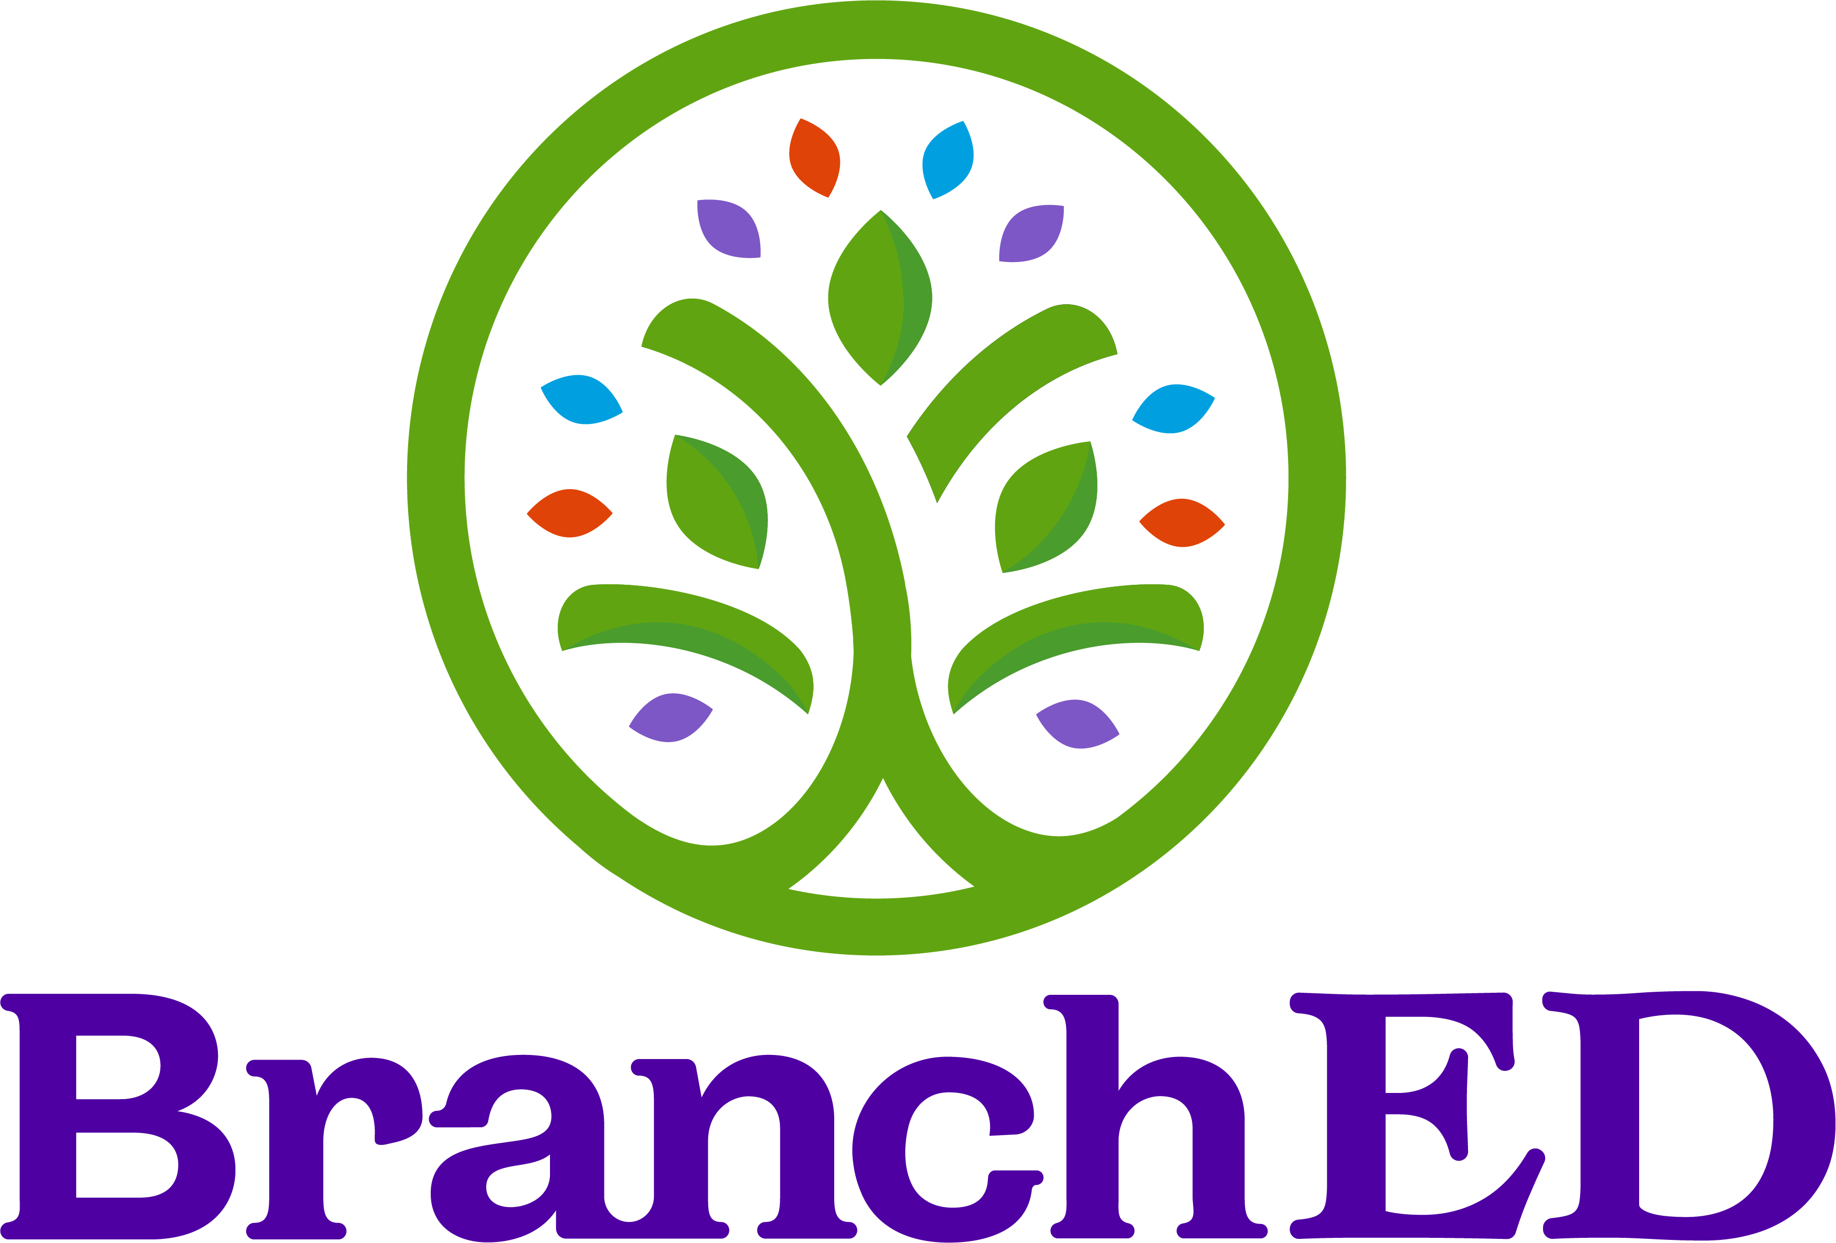

Suggested Citation:
Alvarez McHatton, P., Broughton, A., Collado, C., Coneway, B., Rodriguez, S., Watkins, K., & Zimmer, K. (2023). Framework for the Quality Preparation of Educators: A Diagnostic Tool Focused on Early Literacy. Peachtree City, GA: Branch Alliance for Educator Diversity.
NOTE: Authors are listed in alphabetical order

Revised 08/11/2025



COPYRIGHT © 2023 by the M.E.B Alliance for Educator Diversity, Inc., Austin, Texas.
All rights reserved. No part of this publication may be reproduced or distributed in any form or by any means, or stored in a database or retrieval system, without the prior written consent of M.E.B. Alliance for Educator Diversity, Inc., including but not limited to, in any network or other electronic or cloud storage or transmission, or broadcast for any form of distribution for distance learning.

Published by Branch Alliance for Educator Diversity, an imprint of M.E.B. Alliance for Educator Diversity, Inc., 100 World Drive, Suite 101 Peachtree City, GA 30269.

https://www.educatordiversity.org/

Table of Contents
BranchED Framework for the Quality Preparation of Educators 3
BranchED Framework for the Quality Preparation of Educators: A Diagnostic Tool/Implementation Guide Focused on Early Literacy 3
How to Use the Diagnostic Tool 4
Design Principle: Community of Learners 5
Design Principle: Data Empowerment 5
Design Principle: Intersectional Content 6
Design Principle: Practice-Based Approach 7
Design Principle: Inclusive Instruction 8
Glossary 11

BranchED Framework for the Quality Preparation of Educators

BranchED is pioneering a higher standard of educational excellence. We are a professional services organization and a collective of university faculty and leaders advancing educational excellence by expanding individual capacity, enabling supportive relationships, boosting institutional effectiveness, and collaborating with communities. We believe that every student deserves access to caring, adaptive, and well-prepared teachers and that every teacher deserves preparation that fuses theory with real-world practice. This vision is accomplished through the application of our Framework for the Quality Preparation of Educators. The Framework outlines a roadmap to create teacher preparation programs that meet the needs of our increasingly diverse student body.
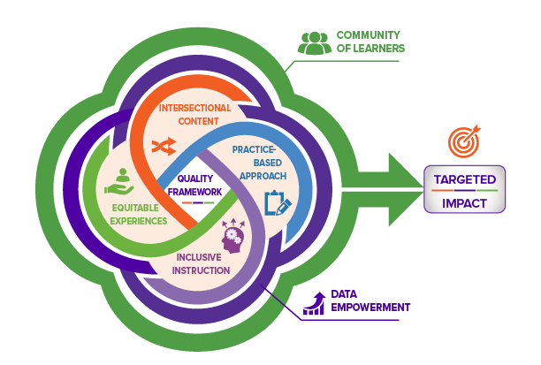

The Framework identifies six critical focus areas that teacher preparation providers can leverage to redesign their programs. Two of these focus areas (Community of Learners and Data Empowerment) provide the foundation for the remaining focus areas: Intersectional Content, Practice-Based Approach, Inclusive Instruction, and Equitable Experiences. It seeks to build high quality educator preparation programs that prepare educators to reflect, respect, and reify the value of all of America’s PK12 school children. It offers educator preparation providers (EPPs) a common vision of what high quality, culturally sustaining educator preparation is, and a coherent and sustained approach to implementing evidence-based practices that accomplish vitally important educational work.

BranchED Framework for the Quality Preparation of Educators: A Diagnostic Tool/Implementation Guide Focused on Early Literacy

Recognizing the importance of early literacy to student success, BranchED recently convened an Early Literacy Joint Action Group comprised of early literacy subject matter experts. Working collaboratively, they reviewed the Framework and developed a diagnostic tool focused on early literacy that can support EPP’s development of high-quality early literacy programming in partnership with their district partners. The tool details each design principle and then provides specifics as to what a high-quality early literacy program looks like along with a sample of evidence that exemplifies the transformative work of the program.

How to Use the Diagnostic Tool

We encourage you to engage early literacy faculty, district partners, and other key stakeholders in applying the diagnostic tool to get a comprehensive understanding of your program’s current level of performance and subsequent action to ensure a high-quality early literacy program.

- Read the indicator descriptor.
- Honestly reflect on your program (i.e., surface what is taking place in your program – the current reality).
- Use the progression template below to determine where you would situate your program currently along the transformation continuum.
- Determine what actions you need to take to address opportunities that emerge from your reflective process.

Not Yet Started  “Haven’t begun”  Elements of the indicator are not yet evident in the program. | Developing  “Planning for it”  Elements of the indicator are not evident, but implementation is in the early development stage. | Progressing  “Working on it”  Implementation is evident, but elements of the indicator need further development/execution. | Sustaining  “Living it”  Full implementation is evident with strong evidence.
“We haven’t begun this work.” | “We are…”  - Talking about it and building background knowledge  - Identifying needs  - Collecting input  - Building consensus and buy-in  - Dismantling barriers  - Planning actions  - Answering what, where, who, when, and how  - Designing the infrastructure for implementation | “We are…”  - Putting plans into action  - Monitoring  - Reviewing and revising curriculum, assessments, field experiences, etc.  - Working on policies, structures, and cultural conditions for full implementation | “We are…”  - Establishing process and routine structures to ensure consistent implementation and fidelity  - Engaging in a systematic continuous improvement process for program improvement

Design Principle: Community of Learners
Quality educator preparation is catalyzed by a broad-based Community of Learners. The Early Literacy Program establishes a community of learners through leadership, shared responsibility for candidate learning, and professional collaboration.
What does a high-quality early literacy program look like?
Community of Learners (what this design principle means)
A strong foundation for a high-quality early literacy program is achieved through the collaboration of a diverse Community of Learners. The literacy program faculty are committed to building this community, fostering shared responsibility for teacher candidates’ learning, and encouraging professional collaboration. It is this collective effort that ensures that teacher candidates possess and demonstrate the essential early literacy skills recognized by stakeholders.
What This Looks Like |  |  |  | Types of evidence to support a rating of Sustaining might include but not be limited to:
- Program faculty and stakeholders collaboratively engage in professional learning to improve teacher candidate performance and their own practice.  - Program faculty have the authority and autonomy to make decisions about the early literacy program with input from stakeholders.  - Program faculty actively build long-term, trusted relationships with PK-12 partners, teacher candidates, community-based organizations, and other groups to build a shared understanding of teacher candidates’ learning related to early literacy competencies and collectively impact PK-12 learning through teacher preparation.  - The program has a process for continuously improving the early literacy program through collaborative engagement and dialogue about current literacy trends, data analysis, and solutions.  - Program faculty and stakeholders seek out and apply research and evidence-based practices in program improvement efforts. |  |  |  | - Documentation of collaborative activities focused on a shared vision for literacy (e.g., a roster of participants, meeting recordings, meeting minutes).  - Documentation of a process for developing a shared list of competencies related to early literacy/ evidence-based practices/ science of reading are explicitly stated.  - Documentation of program improvement efforts and application of research and best practices.  - Documentation of professional learning provided and/or completed by program faculty.
Current Level of Implementation
☒ Haven’t Begun |  | ☐ Planning for It |  | ☐ Working on It |  | ☐ Living It
What are our assets in this area? |  |  |  | What three to five (3-5) steps will you take to move you to the next level?

Design Principle: Data Empowerment
Quality educator preparation is Data Empowered. The Early Literacy Program has an active culture of inquiry, utilizing an authentic and ongoing cycle of evidence-based improvement that begins with asking thoughtful questions, moves through organizational learning and action, and ends with an evaluation of the effectiveness of actions taken.
What does a high-quality early literacy program look like?
Data Empowerment (what this design principle means)
In the context of early literacy, the principle of Data Empowerment refers to the use of data-driven practices and evidence-based approaches in preparing teacher candidates to effectively teach early literacy skills to young children. This principle emphasizes the importance of developing a culture of inquiry for program improvement within the EPP.
What This Looks Like |  |  |  | Types of evidence to support a rating of Sustaining might include but not be limited to:
- Program faculty ask thoughtful questions about early literacy instruction and what data inform these questions.  - Program faculty establish a culture of inquiry where data and evidence are central to decision-making and improvement. This involves collecting and analyzing data related to early literacy instruction, such as teacher candidate performance data, teacher assessments, and feedback from mentor teachers for program improvement efforts.  - Program faculty implement culturally responsive data practices to monitor candidate progression. Culturally responsive data practices take note of teacher candidates’ context, background, interests, strengths, and surrounding information that may affect performance and behavior.  - Program faculty systematically engage internal and external stakeholders in providing feedback and engaging in data analysis and reflection to inform program improvement efforts.  - Program faculty engage in organizational learning, which involves sharing and discussing data, research findings, and evidence-based practices in early literacy instruction among faculty and staff. This collaborative process helps inform decision-making and facilitates the development of effective instructional strategies and approaches for early literacy.  - Program faculty triangulate multiple data sources critically, honestly, and collaboratively to evaluate and revise early literacy instructional practices and content. |  |  |  | - Documentation of a process for systematic collection and analysis of assessment data that is used to evaluate the effectiveness of the early literacy program.  - Evidence of program evaluation, which includes gathering feedback from graduates (e.g., program satisfaction and preparedness to teach early literacy) and seeking input from employing school districts.  - Documentation of program faculty professional learning that involves sharing and discussing data.  - Documentation of partnerships with schools and districts detailing how they collaborate to analyze data on candidate outcomes (e.g., MOUs, meeting agenda/notes).
Current Level of Implementation
☒ Haven’t Begun |  | ☐ Planning for It |  | ☐ Working on It |  | ☐ Living It
What are our assets in this area? |  |  |  | What three to five (3-5) steps will you take to move you to the next level?

Design Principle: Intersectional Content
Quality early literacy educator preparation is grounded in Intersectional Content. Before program completion, teacher candidates demonstrate mastery of content related to learners, learning, the subject matter, content knowledge for teaching, pedagogical knowledge, assessment, and engagement with families and communities. Such knowledge is dynamic, constructed, and overlapping.
What does a high-quality early literacy program look like?
Intersectional Content (what this design principle means)
A strong foundation for a high-quality early literacy program is achieved through grounding early literacy teacher preparation in Intersectional Content, whereby teacher candidates can develop a dynamic and comprehensive understanding of the diverse aspects of early literacy. This prepares them to create inclusive and literacy rich learning environments to address the unique needs of each learner, and to promote equitable literacy outcomes for all children. Steps toward full implementation of the indicator:
What This Looks Like |  |  |  | Types of evidence to support a rating of Sustaining might include but not be limited to:
- The program ensures that practices are aligned with early literacy practices in the field (i.e., Science of Reading, structured literacy, oral language development, evidence-based practices that support multilingual PK-12 students, knowledge of Dyslexia).  - The program faculty ensure the program is standards-aligned and coherent, addressing content, pedagogy, and assessment.  - The program faculty, PK-12 educators, and other key stakeholders collaboratively develop candidate competencies that encompass literacy skills, knowledge, and dispositions that teacher candidates must demonstrate upon completion of the program.  - The program provides access to asset-based pedagogies in early literacy. Asset-based pedagogies view students’ intersectional identities as adding value and strength to classrooms and communities.  - The program ensures teacher candidates' understanding of how to utilize data and research to inform and improve early literacy instruction. |  |  |  | - Documentation of well-designed early literacy curriculum that explicitly integrates intersectional content across courses and field experiences. The curriculum would cover a range of topics related to learners, subject matter, pedagogical knowledge, assessment, common reading difficulties, and family/community engagement, ensuring teacher candidates develop a comprehensive understanding of early literacy.  - Syllabi provide documentation and uses of evidence-based instructional strategies that model and promote the integration of intersectional content in teaching practices. Teacher candidates would engage in discussions, activities, and assignments that explore the intersectionality of diverse learners and the application of early literacy content knowledge in inclusive and culturally responsive ways.  - Documentation of Assessment practices that evaluate teacher candidates' proficiency in intersectional content. Assessments may include performance tasks, portfolios, observations, and reflective assignments that require teacher candidates to demonstrate their knowledge and skills across the identified early literacy areas.  - Documentation of asset-based pedagogies implemented in the classroom (e.g., assignments, assessments, lesson plans, etc.).
Current Level of Implementation
☒ Haven’t Begun |  | ☐ Planning for It |  | ☐ Working on It |  | ☐ Living It
What are our assets in this area? |  |  |  | What three to five (3-5) steps will you take to move you to the next level?

Design Principle: Practice-Based Approach
Quality early literacy educator preparation is experiential and Practice-Based. The early literacy program purposefully engages teacher candidates in direct experience of teaching (practice) and focused reflection, in order to increase knowledge, develop skills, clarify values, and develop the capacity to contribute to diverse communities.
What does a high-quality early literacy program look like?
Practice-Based Approach (what this design principle means)
A practice-based approach in early literacy cultivates teacher candidates’ knowledge, skills, and dispositions through high-quality opportunities to practice combined with feedback and support. Teacher candidates engage in deliberate practice with a focus on improving performance through repeated rehearsal and feedback in increasingly complex settings.
It equips educators with the knowledge, skills, and reflective capacity necessary to foster early literacy development and contribute to the educational success of children in diverse communities.
What This Looks Like |  |  |  | Types of evidence to support a rating of Sustaining might include but not be limited to:
- The program faculty and PK-12 partners model evidence-based literacy instruction and activities in diverse settings (e.g., community, schools, inclusive classrooms, co-taught classrooms, etc.).  - The program faculty and PK-12 partners provide literacy coaching for teacher candidates.  - The program ensures coursework and field experiences are scaffolded to support teacher candidates’ skill development in early literacy instruction.  - The program provides teacher candidates opportunities to engage with families and communities in meaningful ways.  - The program provides teacher candidates opportunities to engage in literacy-based video observation, microteaching, simulations, and purposeful practice of literacy activities consistent with evidence-based literacy practices (e.g., Science of Reading, structured literacy).  - The program provides teacher candidates opportunities to reflect on literacy instruction and assessment.  - The program provides teacher candidates with a wide variety of field experiences (e.g., co-taught, diverse settings) that model the use of high-quality, evidence-based literacy practices.  - The program engages teacher candidates in discussions about how to counter systemic issues in schools by having deep content knowledge, inclusive practices, and having high expectations for student learning. |  |  |  | - Field experience documentation- records of teacher candidates' field experiences, such as student teaching placements, internships, or practicum experiences. These documents can demonstrate the duration and quality of teacher candidates' direct experiences in classroom settings, highlighting their involvement in teaching, observing, and interacting with students.  - Lesson Plans and Instructional Materials- Program faculty can share samples of lesson plans, instructional materials, and assessments created by teacher candidates during their practice-based experiences. These artifacts showcase teacher candidates' ability to design and implement effective early literacy instruction, tailored to the specific needs of diverse learners.  - Teacher candidate tools- teaching portfolios, candidate reflections, journals, video observations, simulations, and performance assessments that document TCs' experiences, insights, and challenges in early literacy teaching engagements.  - Syllabi that illustrate the use of evidence-based literacy instruction and activities (Science of Reading).  - Documentation related to how the program provides teacher candidates with opportunities for meaningful field experiences in diverse educational settings.
Current Level of Implementation
☐ Haven’t Begun |  | ☐ Planning for It |  | ☐ Working on It |  | ☐ Living It
What are our assets in this area? |  |  |  | What three to five (3-5) steps will you take to move you to the next level?

Design Principle: Inclusive Instruction
Quality educator preparation fosters Inclusive Instruction. Inclusive instruction minimizes or removes barriers to learning or assessment and supports the success of all learners, while ensuring that academic standards are not diminished. Such pedagogy includes the integration of culturally and linguistically sustaining practices, social and emotional learning, cognitive science, and trauma informed care.
What does a high-quality early literacy program look like?
Inclusive Instruction (what this design principle means)
A high-quality early literacy program ensures that teacher candidates are equipped with the knowledge, skills, and resources to provide Inclusive Instruction that minimizes barriers to learning, supports the success of all learners, and ensures that academic standards are met. The program values the intersectional identities of children, promotes social-emotional well-being, applies evidence-based instructional strategies, considers trauma-informed care, and actively engages families and communities in the learning process.
What This Looks Like |  |  | Types of evidence to support a rating of Sustaining might include but not be limited to:
- The program exemplifies an asset-based approach to literacy instruction. Teacher candidates are prepared to value and build upon the cultural and linguistic assets that children bring to the learning environment.  - The program values the funds of knowledge families and communities possess; families and communities are represented through readings, course materials, and purposeful practice opportunities. There is evidence of diverse voices, scholars, and materials.  - The program provides opportunities for teacher candidates to see culturally responsive and linguistically sustaining instruction in action in PK-12 and higher education settings.  - Teacher candidates are exposed to multiple perspectives through instruction, materials, and communication styles.  - The program assesses teacher candidates’ use of culturally responsive and linguistically sustaining pedagogy.  - The program faculty engage in professional development and proactively respond to inequities in education settings (higher education and PK-12).  - The program ensures that Social and Emotional Learning (SEL) practices are integrated into literacy instruction to help children develop the social and emotional competencies necessary for academic success.  - The program incorporates evidence-based practices (e.g., Science of Reading) into early literacy instruction. |  |  | - Documentation of use of culturally and linguistically sustaining practices (syllabi for courses documenting coursework or experiences to help future educators understand and respect the intersectional identities and backgrounds of their students.  - Documentation of syllabi that includes diverse voices and perspectives.  - Documentation of program assessments that assess teacher candidates’ use of culturally responsive and linguistically sustaining pedagogy.  - Documentation of program faculty research-based cognitive science principles into early literacy instruction (Science of Reading).  - Documentation of workshops, readings, or professional development related to SEL practices and how they can be integrated to early literacy instruction.
Current Level of Implementation
☐ Haven’t Begun | ☐ Planning for It |  | ☐ Working on It |  | ☐ Living It
What are our assets in this area? |  |  | What three to five (3-5) steps will you take to move you to the next level?
Design Principle: Equitable Experiences
Quality educator preparation ensures Equitable Experiences for all teacher candidates. The EPP provides a multi-layered, holistic system of candidate-specific research-based supports, just-in-time interventions, and enrichment experiences that are informed by data and the identification of candidate-specific needs. Academic and social supports are regularly provided and actively monitored to determine whether activities are effective in meeting teacher candidates’ needs and enabling their achievement.
Equitable Experiences (what this design principle means)
Equitable Experiences for teacher candidates are key to establishing a high-quality early literacy program that supports teacher candidates’ needs. Such programs understand that teacher candidates possess assets, including funds of knowledge that can serve as a foundation upon which to build the knowledge, skills, and dispositions necessary as a highly effective educator. They also understand that teacher candidates enter their program(s) with unique needs and circumstances.
What This Looks Like |  |  |  | Types of evidence to support a rating of Sustaining might include but not be limited to:
- The program exemplifies an ethic of care and fosters a sense of belonging for all teacher candidates.  - The program positions advising as an act of advocacy in helping teacher candidates bridge demands (academic and personal) to ensure candidate success in the progression and completion of the program.  - The program faculty establish mentorship programs or support networks where diverse teacher candidates are paired with experienced educators or peers who can provide guidance, support, and advice throughout their teacher education journey.  - Program faculty engage in targeted recruitment and outreach efforts to attract diverse teacher candidates.  - Program faculty collaborate with district partners and community stakeholders to design and implement induction supports for new and inexperienced teachers who are beginning their teaching career.  - Program faculty regularly analyzes teacher candidate literacy learning data and implements intervention plans to ensure that teacher candidates are developing the knowledge, skills, and dispositions necessary for success in teaching experiences and program literacy assessments. |  |  |  | - Documentation of individualized support plans for each candidate based on data and assessments of their strengths and areas for growth. These plans outline specific interventions and supports tailored to each candidate's needs, including academic tutoring, mentoring, or targeted professional development related to early literacy.  - Documentation of the use of research-based interventions for providing high-quality support to teacher candidates. These practices are grounded in evidence and are effective in addressing candidate needs.  - Documentation of resources, workshops, or coaching sessions to address immediate needs as they arise, such as addressing specific early literacy knowledge gaps.  - Documentation of regular monitoring and evaluation. Program faculty regularly monitor and evaluate the effectiveness of the supports and interventions provided to teacher candidates.
Current Level of Implementation
☐ Haven’t Begun |  | ☐ Planning for It |  | ☐ Working on It |  | ☐ Living It
What are our assets in this area? |  |  |  | - What three to five (3-5) steps will you take to move you to the next level?

Glossary
Asset-Based Pedagogies: Pedagogies that focus on the strengths that diverse classrooms bring to the classroom. Views students’ languages, experiences, communities, and cultures as a resource.
Culturally Responsive Instruction: An approach to instruction that honors students’ cultures, languages, and experiences.
Data Collection: The act of gathering all facts, figures, statistics, and other information for analyses and assessments.
Dyslexia: Defined by the International Dyslexia Association as:
Dyslexia is a specific learning disability that is neurobiological in origin. It is characterized by difficulties with accurate and/or fluent word recognition and by poor spelling and decoding abilities. These difficulties typically result from a deficit in the phonological component of language that is often unexpected in relation to other cognitive abilities and the provision of effective classroom instruction. Secondary consequences may include problems in reading comprehension and reduced reading experience that can impede growth of vocabulary and background knowledge.
Ethic of Care: Grounded in Noddings’ work, this theory argues that caring should be at the heart of the educational system. It is based on a reciprocal relationship between the “one caring” and the “cared for.”
Early Literacy: Refers to the skills and knowledge children need to learn to read and write. The focus is on learning sounds, words, and language.
Early Literacy Competencies: Foundational skills, knowledge, and attitudes that children typically develop before they can read and write in a conventional sense. These competencies are critical for later reading and writing success and include oral language, phonemic awareness, phonics, fluency, vocabulary, and comprehension.
Evidence-Based Practices: Practices for teaching reading that are grounded and proven in research.
​​Field Experience: Applied experiences that are completed prior to student teaching. They can take place in community or PK-12 settings and are scaffolded, allowing pre-service teachers to move from observation to independent and small-group instruction.
Funds of Knowledge: Collections of knowledge-based cultural practices that are a part of families’ and communities’ knowledge, assets, and cultural ways.
Intersectional Identities: Personal and social identities that we possess.
Literacy Coaching: Coaching conducted by an instructional coach with specialized knowledge in literacy. This coaching may include training, observations, modeling lessons, and providing feedback.
Multilingual Students: Students who speak a home language(s), are in the process of acquiring English, and are developing fluency in multiple languages.
Oral Language Development: Refers to the development of a complex system that relates sounds to meaning. Oral language includes 5 components: phonology, syntax, semantics, morphology, and pragmatics.
Partnerships: A reciprocal, well-defined relationship in which all participating members achieve common goals (e.g., EPP and district partnership) and engage in a process to monitor effectiveness.
Pedagogical Knowledge: The specialized knowledge that teachers have about teaching and learning.
PK-12 Students: Preschool, elementary, and secondary school students enrolled through 12th grade.
Science of Reading: Scientifically based instruction grounded in the study of the relationship between cognitive science and educational outcomes.
Simulations: Instructional scenarios that allow learners the opportunity to apply what they have learned in a controlled environment.
Stakeholders: Any individual or organization interested and/or involved in the operation and/or outcomes of the educator preparation program and who are also impacted by the transformation process (e.g., university faculty, schools, districts, teacher candidates, community groups, businesses, community members, community education services providers, community colleges, etc.).
Structured Literacy: An approach to teaching literacy that integrates speaking, listening, reading, and writing by providing explicit, systematic, diagnostic-prescriptive instruction in phonological and phonemic awareness, sound-symbol correspondence (phonics), syllables, morphology, semantics, and syntax.
Teacher Candidates: Individuals participating in an educator credentialing program in preparation for professional education positions. These individuals have met specific requirements to be admitted to the program or are approved for coursework and field/clinical experiences. (Synonymous with Student Teachers).

International Dyslexia Association. (2002). Definition of dyslexia. https://dyslexiaida.org/definition-of-dyslexia/
Noddings, Nel. (1984). Caring, a feminine approach to ethics & moral education. Berkeley: University of California Press.
Vélez-Ibáñez, C. G. & Greenberg, J. B. (1992). Formation and transformation of funds of knowledge among U.S.-Mexican households. Anthropology & Education Quarterly, 23(4), 313-335.

