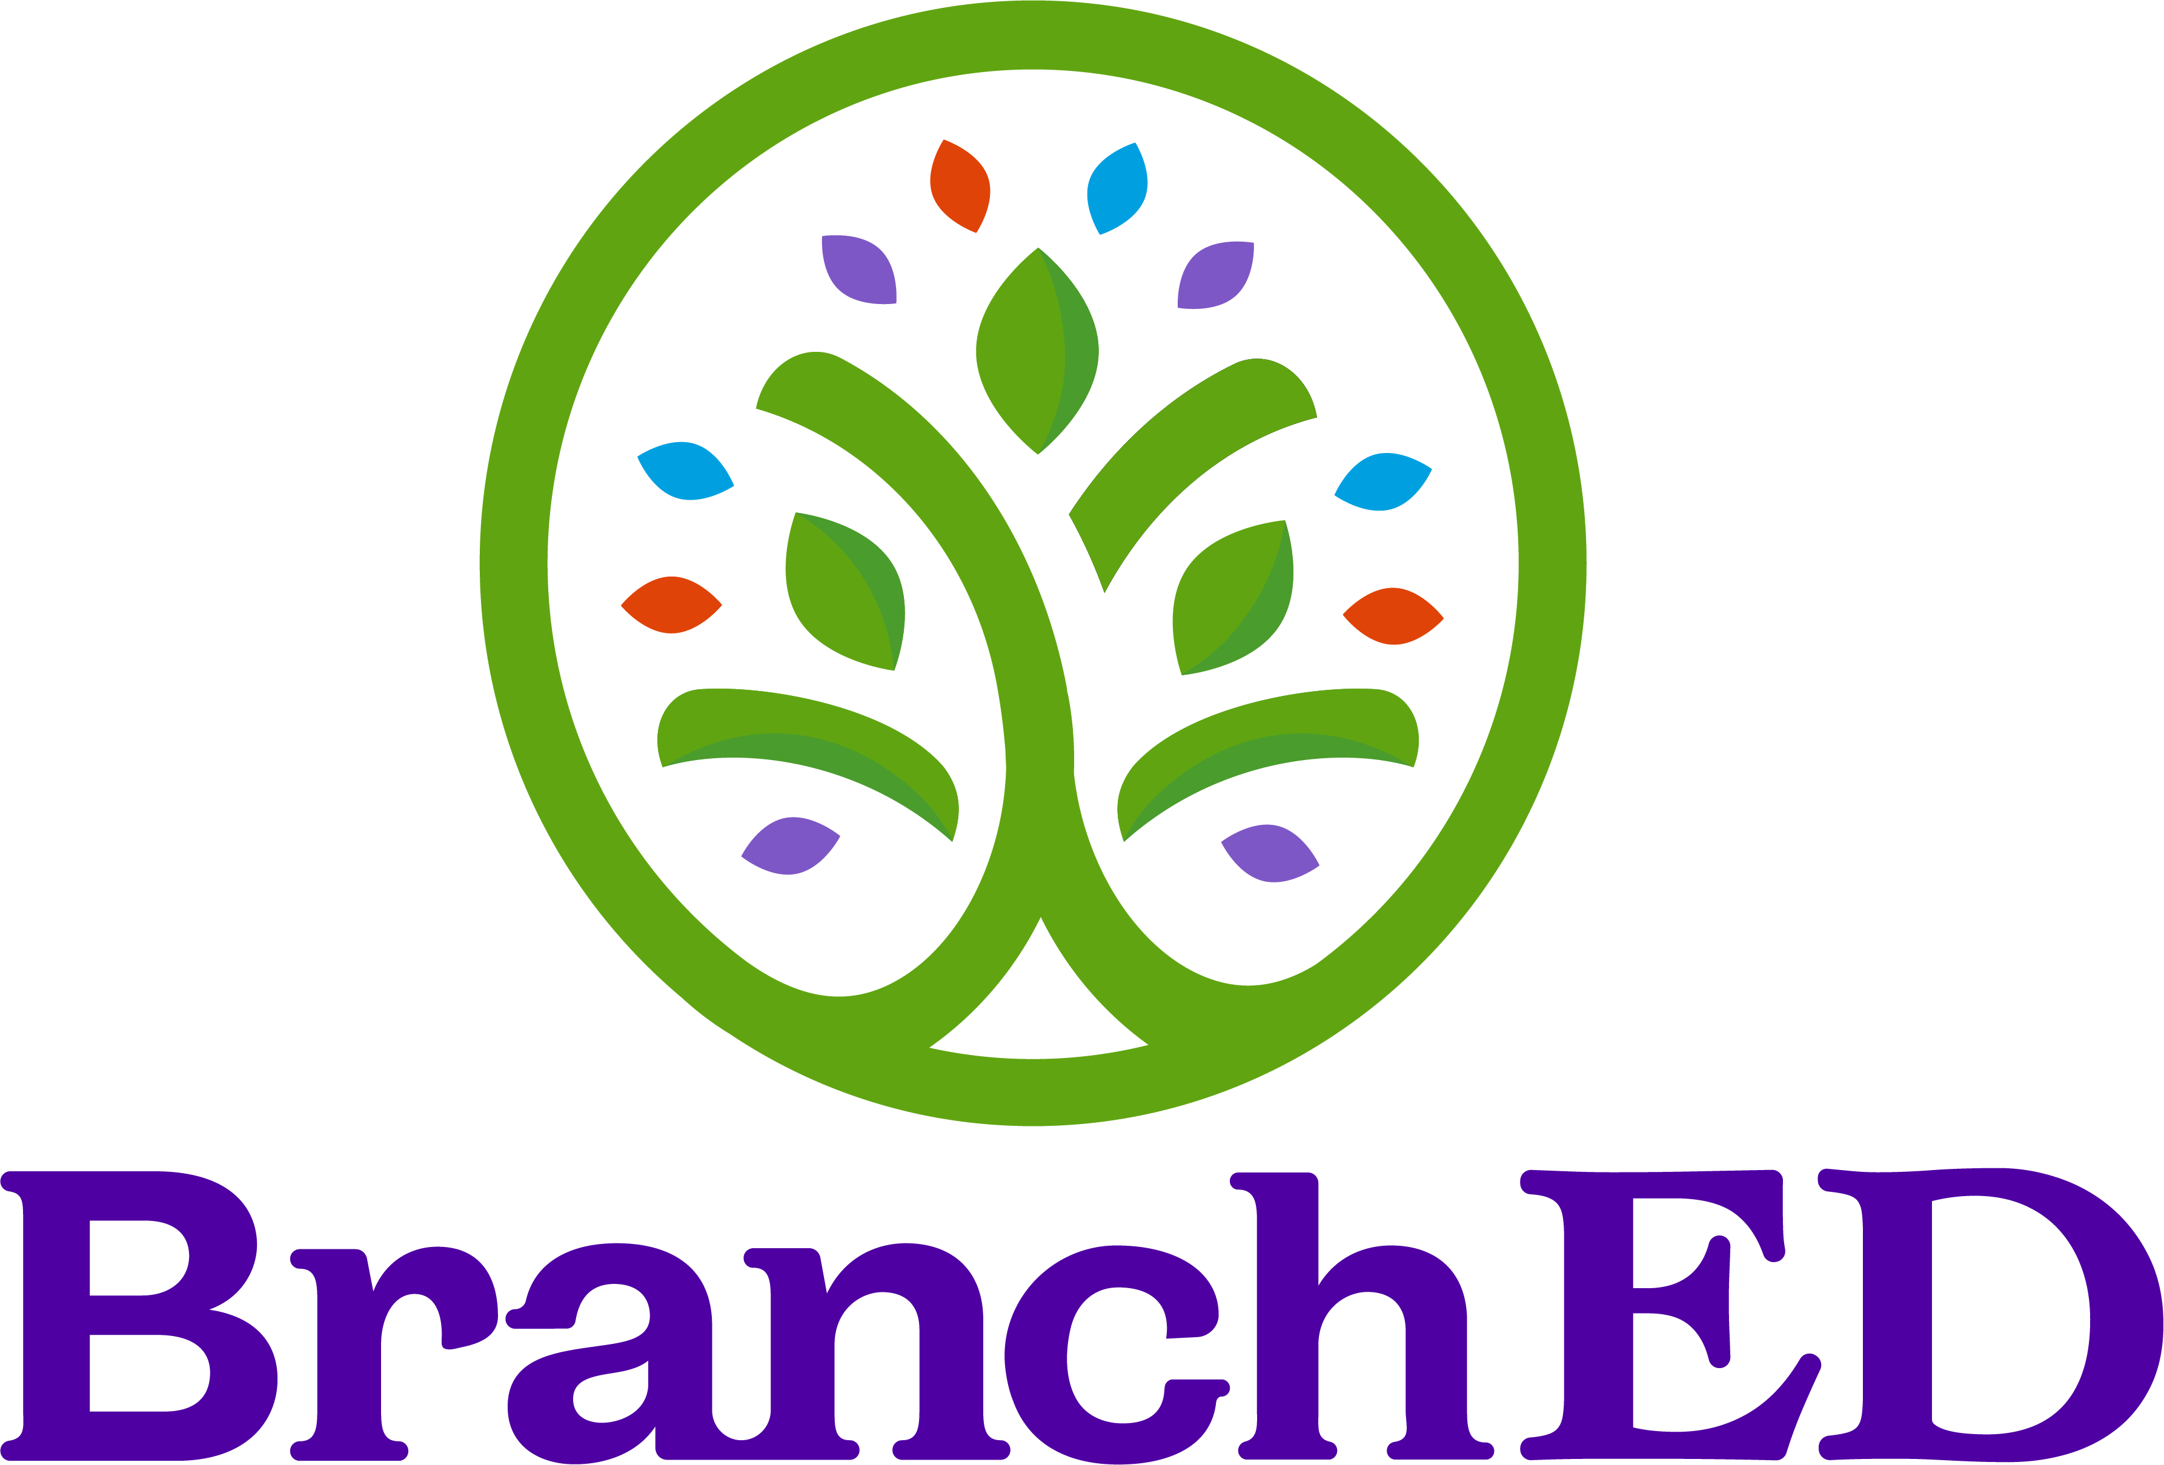

Sustainability Plan Template
(for early-stage, planning, or newly launched partnerships)
Purpose
This plan captures the essential strategies the partnership will use to sustain the innovative pathway over the next 2–3 years, with a focus on near-term stability, clarity of roles, and foundational systems.

Fillable Template with Prompts

Focus | Prompt | Example
Pathway Snapshot | Pathway Name: | → Enter pathway name
Pathway Snapshot | Pathway Model (e.g., Residency, GYO, RAP): | → Brief description
Pathway Snapshot | Partner Organizations: | → List district(s), EPP(s), and other partners
Pathway Snapshot | Target Candidate Population(s): | → Who is this pathway designed to serve?
Pathway Snapshot | Current Stage of Development: | ☐ Planning  ☐ Pilot  ☐ Year 1 Implementation  ☐ Other:
Sustainability Priorities (Next 2-3 Years) | Top 2–3 Sustainability Goals: | → What must be sustained or stabilized in the near term for the pathway to continue?
Sustainability Priorities (Next 2-3 Years) | Key Risks to Sustainability: | → Funding, staffing, enrollment, policy, partnership capacity, etc.
Sustainability Priorities (Next 2-3 Years) | Immediate Opportunities to Strengthen Durability: | → Quick wins or near-term strategies already underway or planned
Partnership and Governance | Primary Decision-Making Structure: | → Who makes key decisions and how?
Partnership and Governance | Roles and Responsibilities: | → Briefly describe the responsibilities of each partner
Partnership and Governance | Communication and Coordination Routines: | → Meeting frequency, communication channels, etc.
Partnership and Governance | Formal Agreements in Place or Planned: | → MOUs, data-sharing agreements, contracts
Funding and Resources | Candidate Funding Level | → What constitutes sufficient support to sustain the candidate throughout the program? (Indicate actual dollar amount per candidate)
Funding and Resources | Current Funding Sources: | → List grants, district funds, EPP contributions, in-kind supports
Funding and Resources | Known Funding Gaps or Dependencies: | → What funding is time-limited or uncertain?
Funding and Resources | Near-Term Strategy to Sustain Core Components: | → What actions will be taken if current funding changes?
Program Quality Non-Negotiables | Core Program Elements That Must Be Preserved: | → What defines program quality and cannot be compromised?
Program Quality Non-Negotiables | Elements That Can Be Adapted Over Time: | → Where is flexibility possible?
Program Quality Non-Negotiables | Minimum Staffing and Capacity Requirements: | → Mentors, supervisors, coordinators, etc.
Data and Continuous Improvement | Core Data Indicators Tracked: | → Candidate outcomes, partnership indicators, district impact, etc.
Data and Continuous Improvement | How Data Are Reviewed and Used: | → Who reviews the data and how often?
Data and Continuous Improvement | Responsible Partner(s): | → Who owns data collection and improvement actions?
Priority Actions and Ownership | Top 3 Sustainability Actions (Next 12 Months): | → For each action:  Action  Responsible Party  Timeline
Priority Actions and Ownership | Date for Sustainability Plan Review: | → Enter date

